# Shaping Up

<http://campus.codeschool.com/courses/shaping-up-with-angular-js/level/1/section/1/video/1>

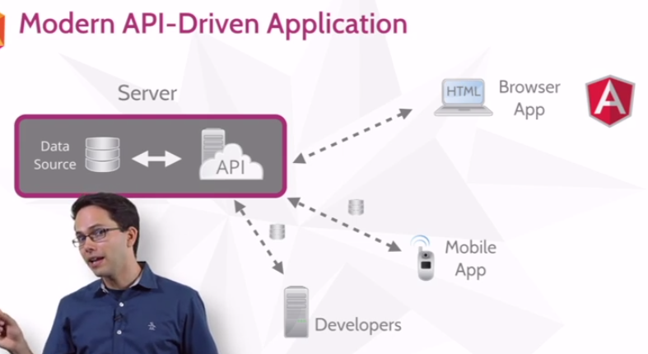

libraries

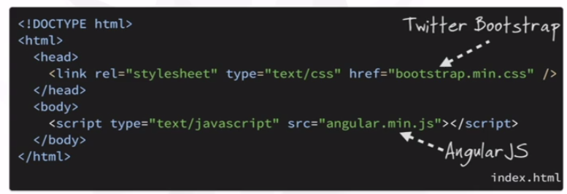

Module (obsolete style, see below !!)

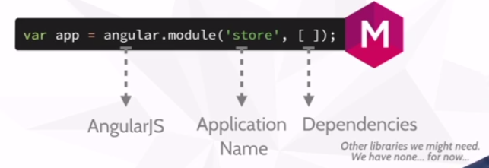

Directive (i.e. link html & js)

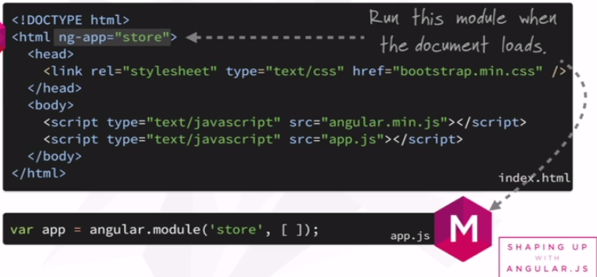

Controller within closure with property „product“ + Json data

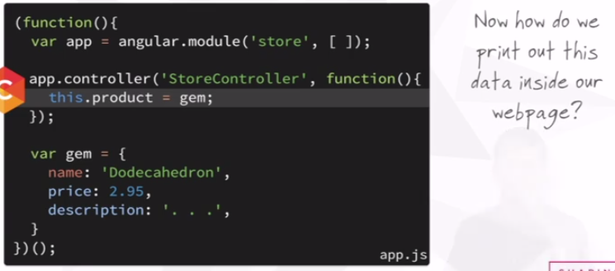

Attach …

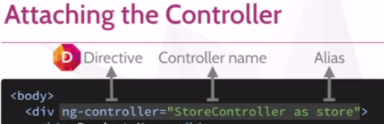

… access from within Html (assigned to div, only available within div)

Tricky: Html calls controller <-> presenter calling Html !!

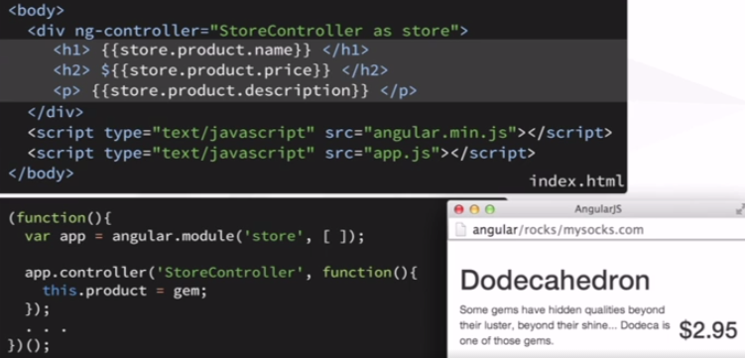

ngShow Directive

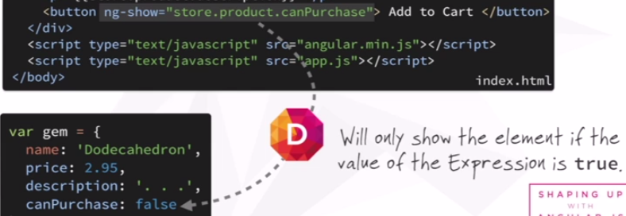

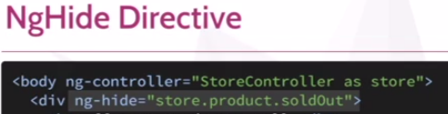

Directive to iterate through array …

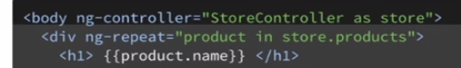

Summary

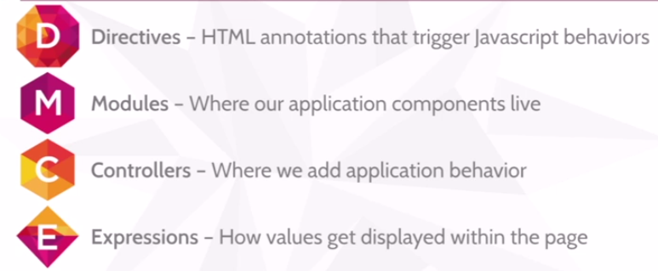

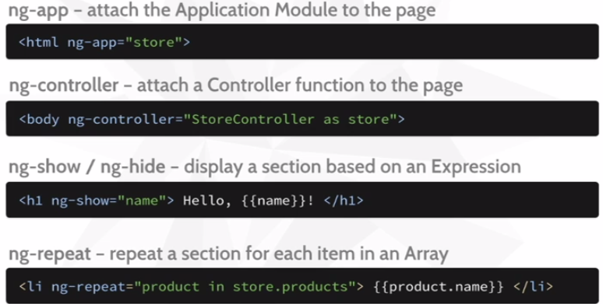

-----------  
-----------

Level 2

Pipe & filter -> display

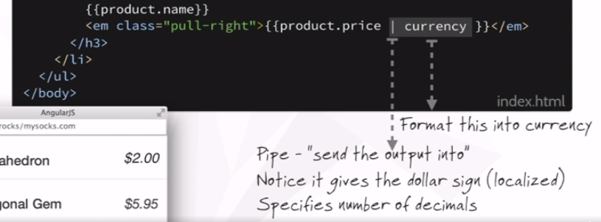

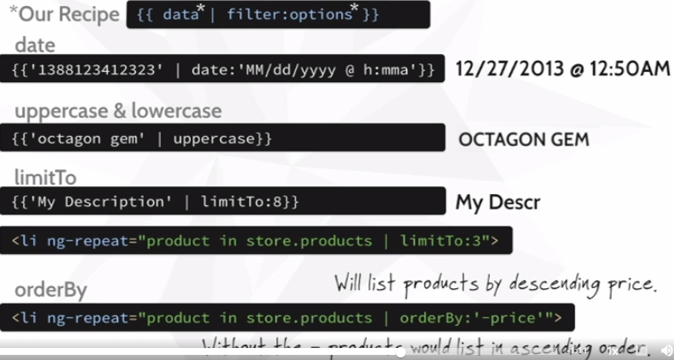

String within Date Filter (tricky!)



<img ng-src=“{{product….full}}“/> … otherwise loaded before angular!!

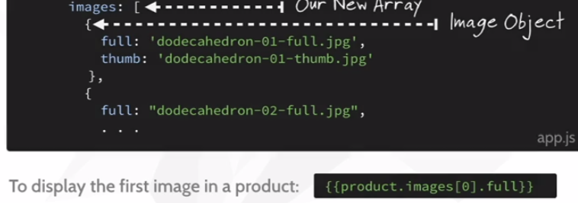

React to „length“ of array



Bootstrap „tab“ + angular „init“  
ng-init -> evaluate expression in current scope  
ng-class -> change color of „hoover-over button“

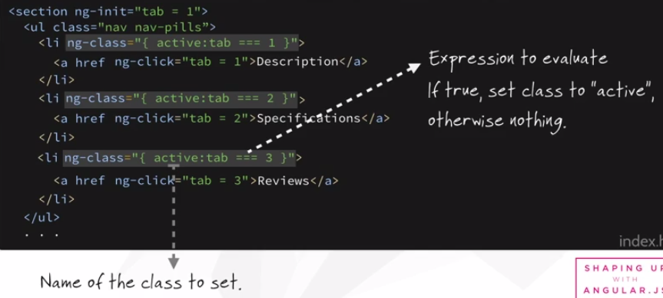

Assign „panel“ dynamically (onClick)

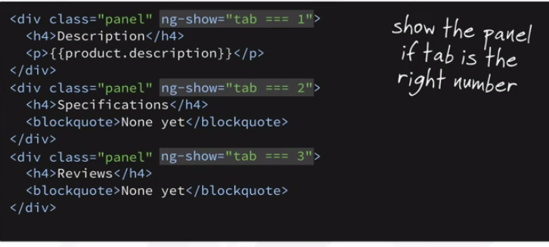

Pull logic out of Html !!



Important:  
ng-controller + alias „panel“  
ng-click -> sets controller value  
ng-class -> highlights selected button  
ng-show -> shows appropriate <div>  
{{product.xxx}} -> prints value of selected category

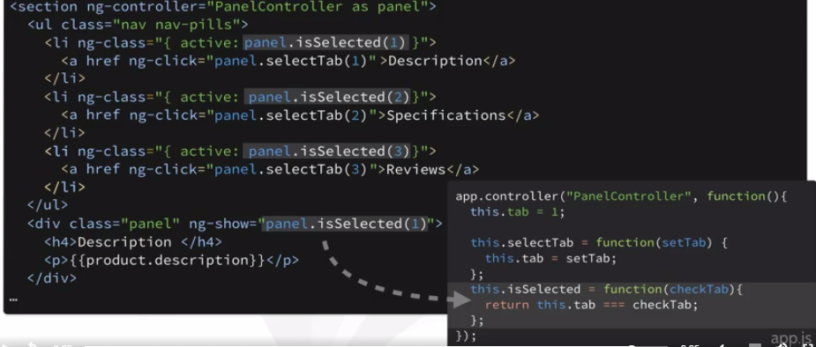

JS check for „null“ values  
-> even better: **if(!setCurrent)**

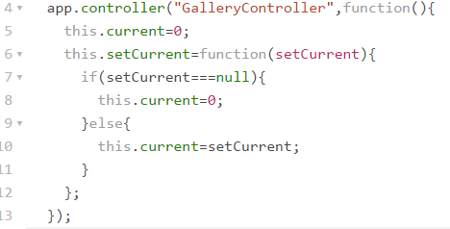

Use selected value to choose image (2-way data binding -> ng-src)

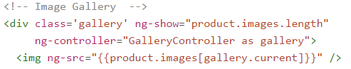

Tricky: no „{{tab}}“ variable defined explicitely…

-----------  
-----------

Level 3

Forms + variables -> model

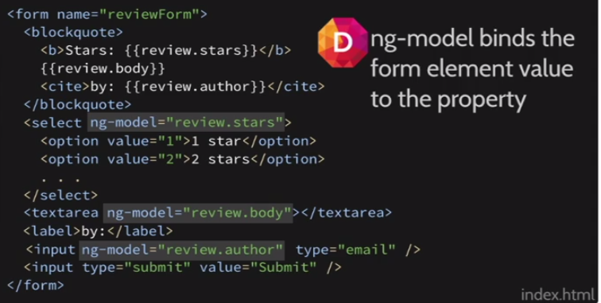

More binding …

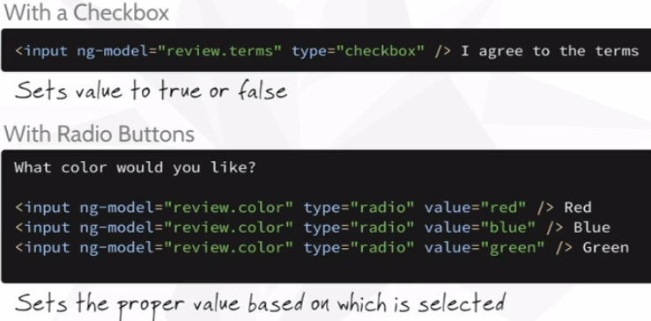

How to define „review“ variable (i.e. DataObject) in the most elegant way?  
1) js -> controller  
2) html -> ng-controller  
short-cut -> html -> „ng-init“

How to submit form?  
ng-submit -> call function

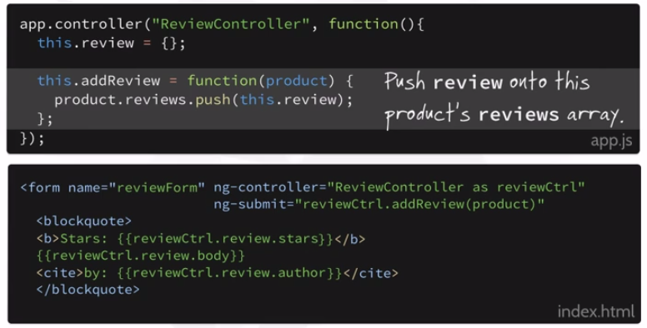

… and reset form input (2-way binding)

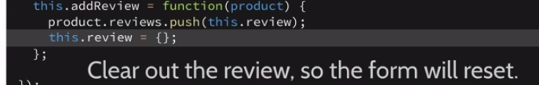

Javascript -> empty object & add to array

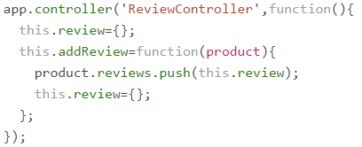

Validate

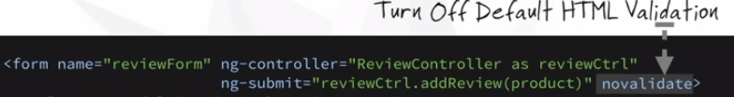

Validation (on Form)

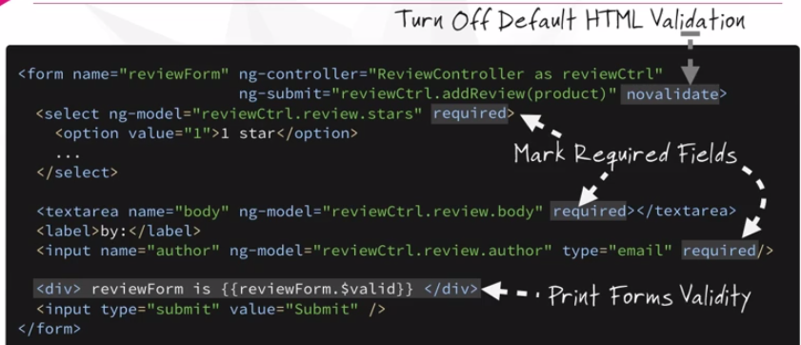

Validation (on Submit)

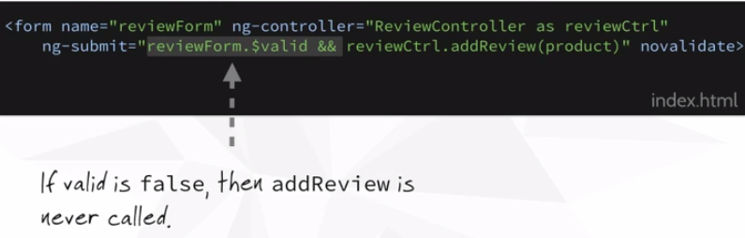

Highlight fields

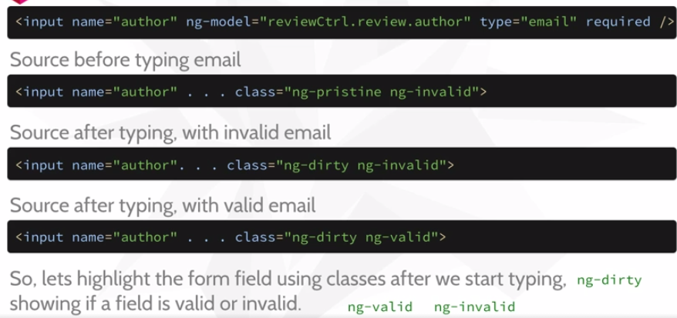

Valid -> Styles (no border, if „pristine“, i.e. un-touched)

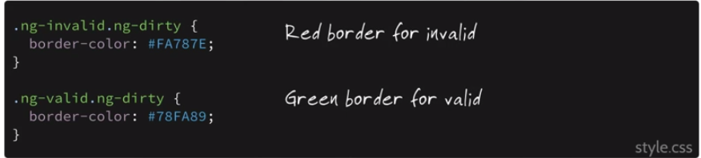

Rules

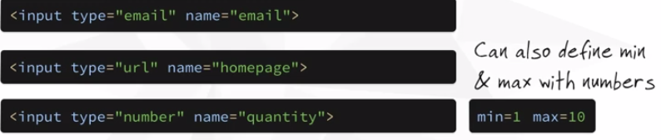

-----------  
-----------

Level 4

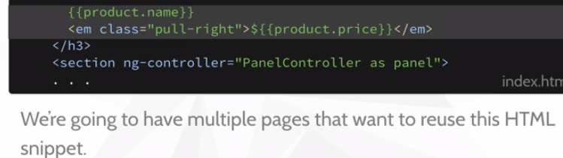

Snip & include (Ajax)

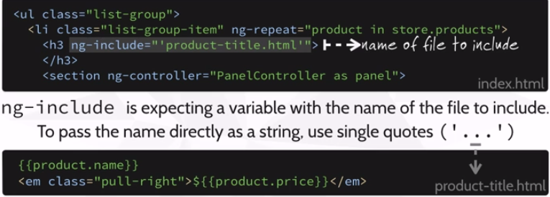

Html -> structure  
Directive -> behaviour -> tells what it does  
Custom Directive -> Custom Tags -> Expressiveness  
-> Template-Expansion

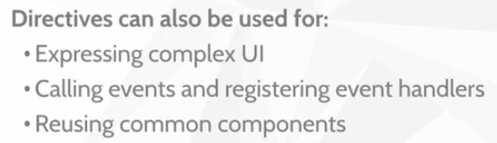

How to …

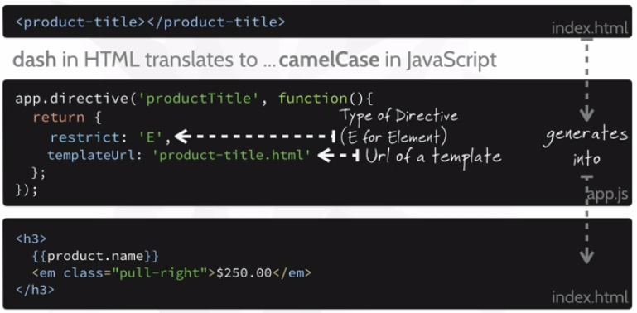

‚E‘ versus ‚A‘ -> element versus attrbute

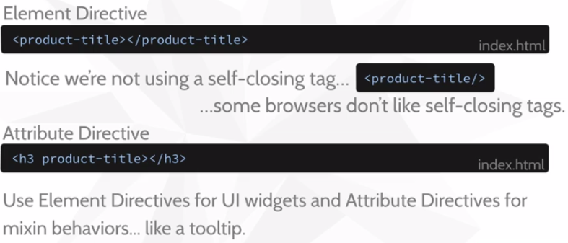

Move Controller & it’s alias (usually within Html) into custom directive

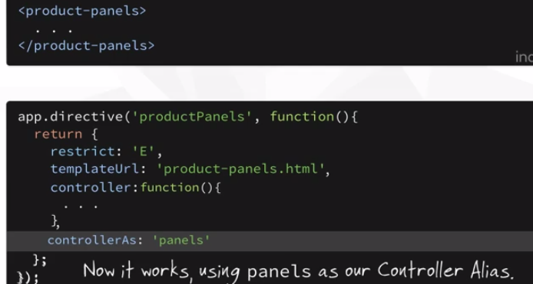

-----------  
-----------

Level 5

Modularize

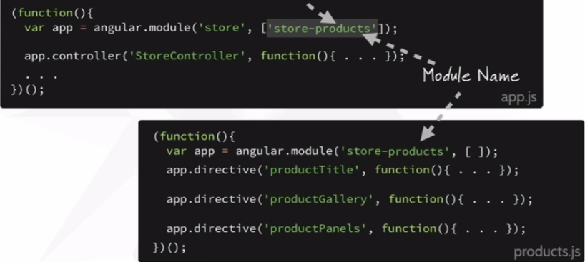

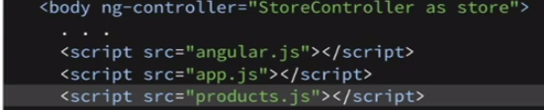

Live Date

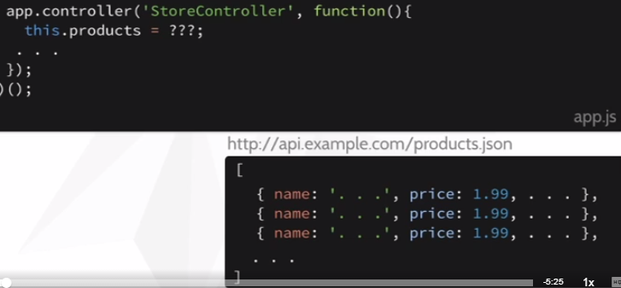

http – json -> via promise (asynch)

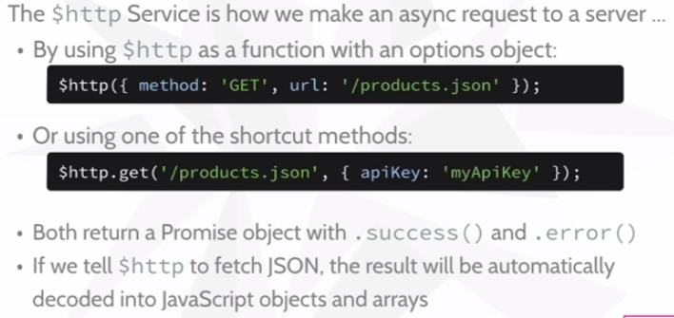

Dependency injection

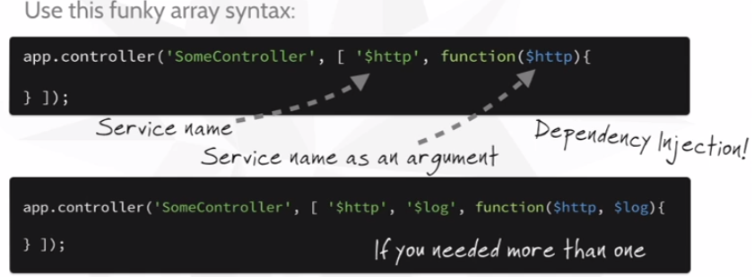

At runtime:

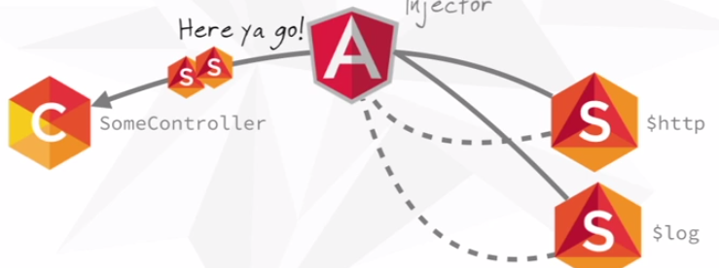

„this“ not available upon call-back !!

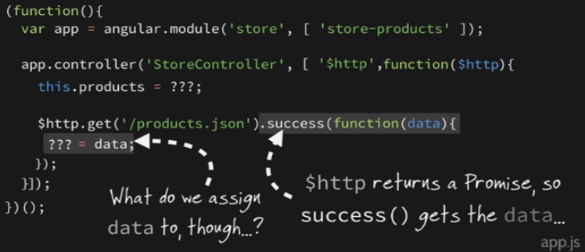

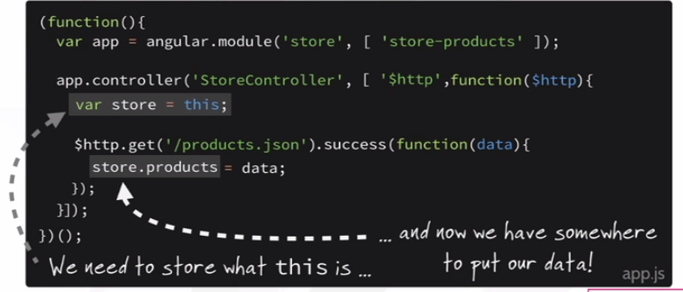

Auto-update of empty array (2-way binding)

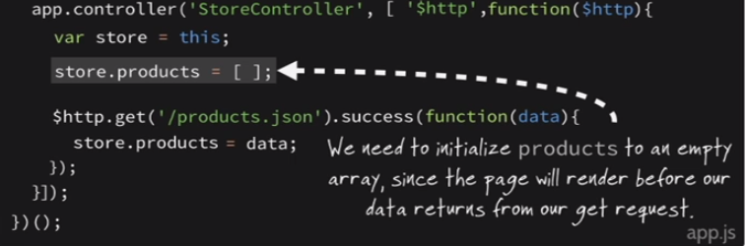

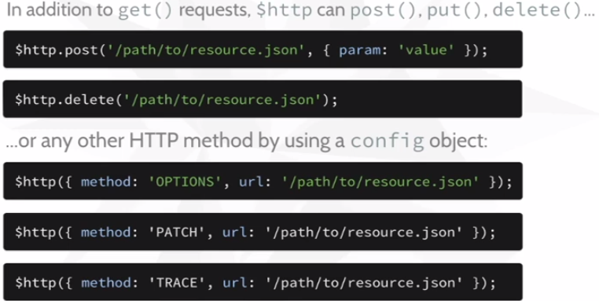

Put … put at specified location -> new or update (CRUD)  
Post … let server handle it -> new only  
-> REST: both unsafe, at least „put“ idempotent

# Staying Sharp

<http://campus.codeschool.com/courses/staying-sharp-with-angular-js/level/1/section/1/video/1>

Using page templates -> html + css + js  
templates -> pages -> [xxx] -> index.html

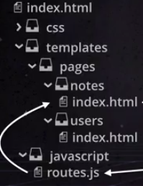 … exercises: … 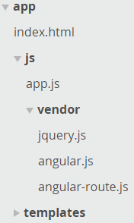

How to -> 4 steps

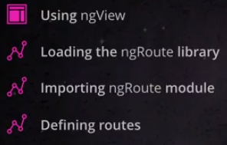

Multiple ng-views on one page  
-> rather not  
-> divide page into multiple parts instead

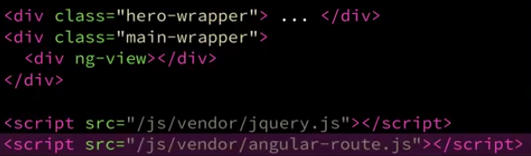

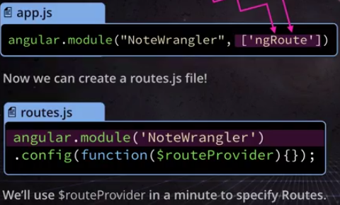

Don’t do this anymore …



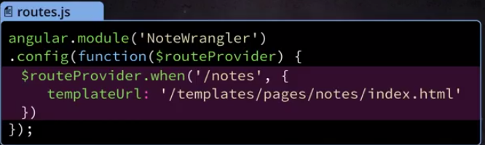

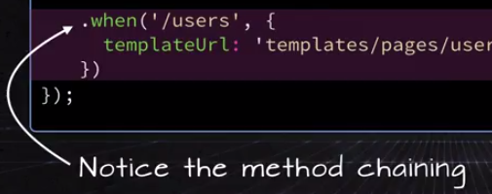

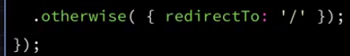



Retrieve data (for template) via controller -> use controller within template !!

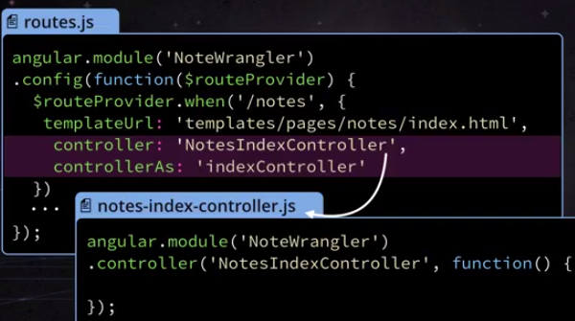

e.g. $http service

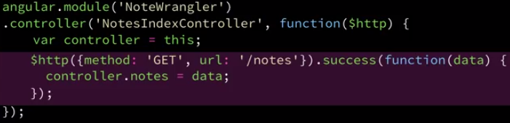

Display dynamically (json + anguler <-> XML + XLST)

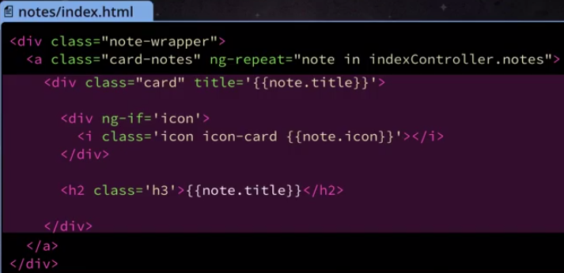

Single node view

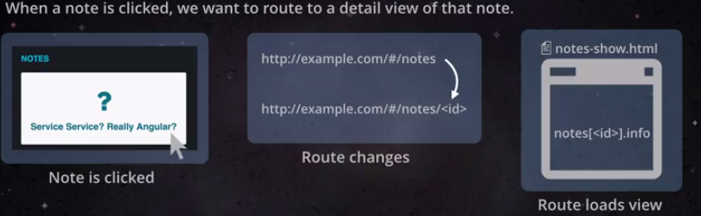

Define Parameter & use it …

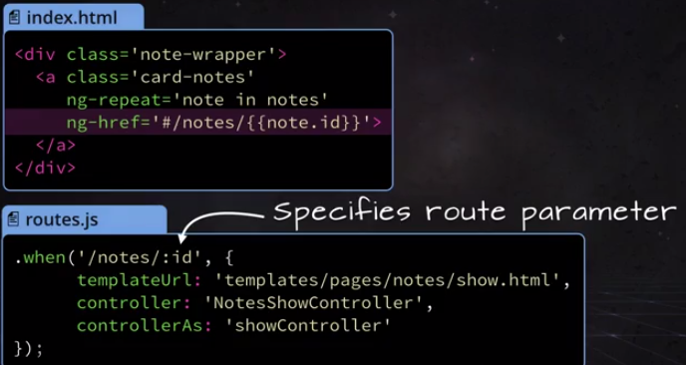

… (but before: ) pass it …

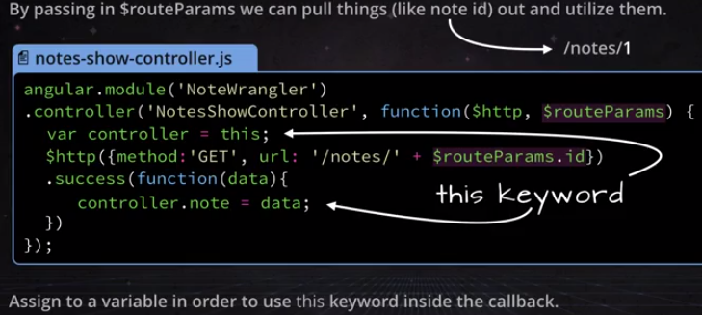

… finally show data

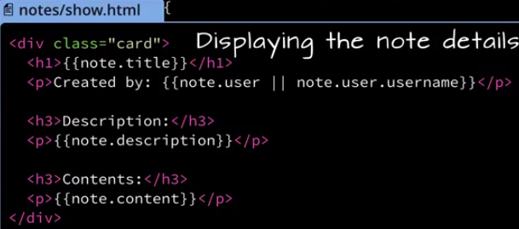

Post with exception handling + display…

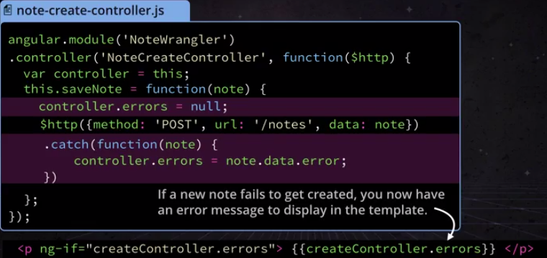

Excercise 1.10 -> look above for ng-submit …

-----------------  
Part 2  
----------------

$scope instead of alias (within directive)   
-> scope shared between directive & controller

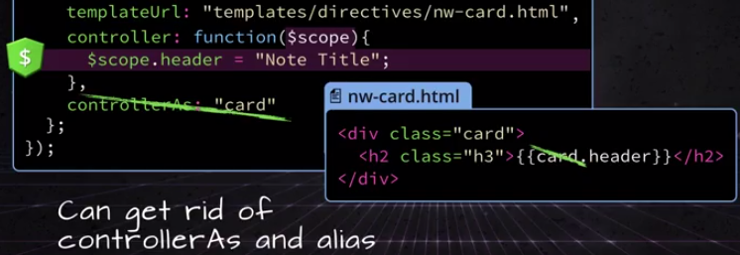

Use $scope   
-> additional dependency !!  
-> additional param

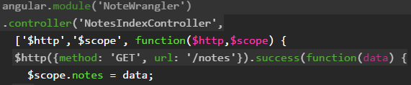

Directive -> own $scope for each ng-repeat

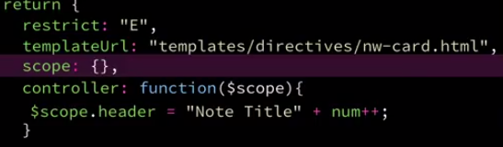

… no access to ANYTHING from parent !!

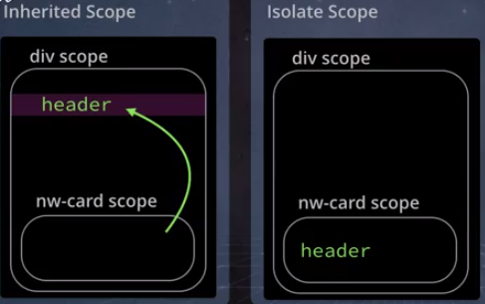

… pass as param into directive

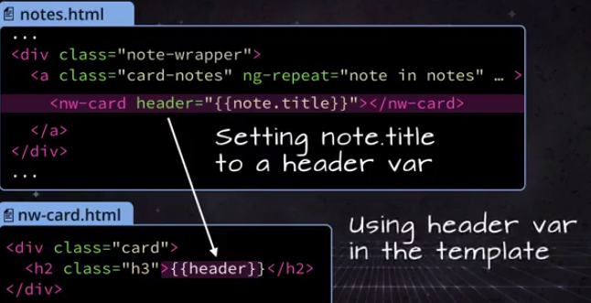

… prepare for that:

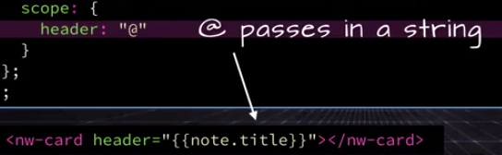

„=“ instead of „@“ (!!)

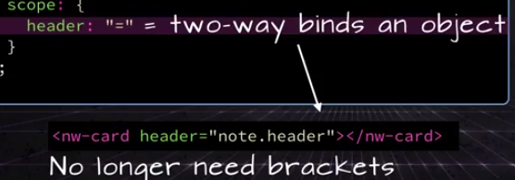

Handle „onClick“ with jQuery,  
but not inside the controller !!  
-> use link for DOM manipulation  
-> use element (to not search the whole DOM)

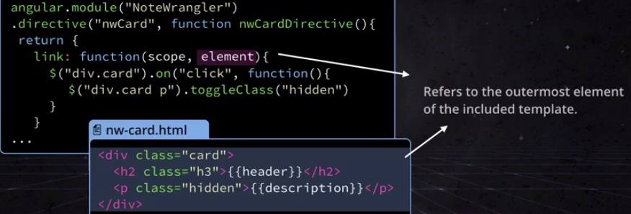

… straight to element

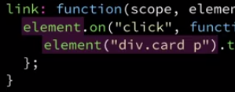

FYI -> access attributes of directive

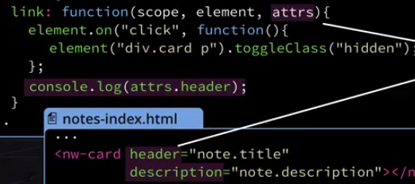

--------------  
use external lib …

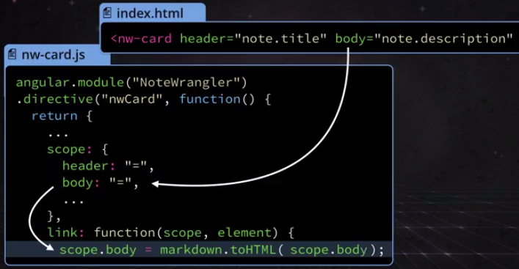

… have injected html interpreted  
-> make it trusted  
-> use ng-bind instead of {{ }}  
-> no „strict contextual escaping“

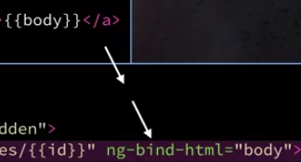 

--------------------  
3  
-------------------

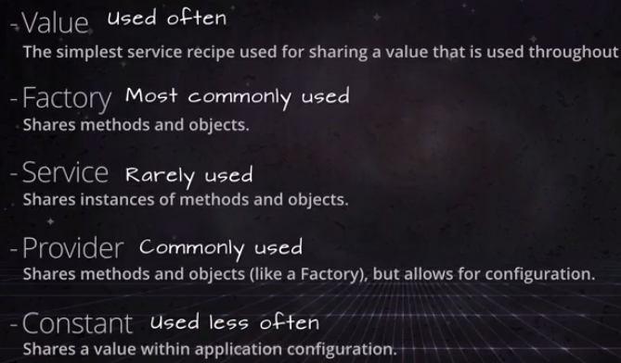

With or without configuration:

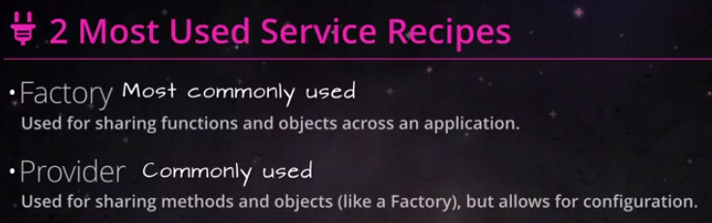

Naming convention

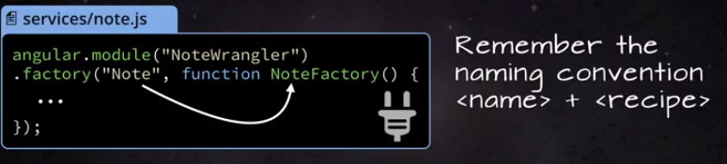

More naming:  
get -> all  
post -> create (see CRUD above)  
Warning: Syntax Errors below !! -> return {};

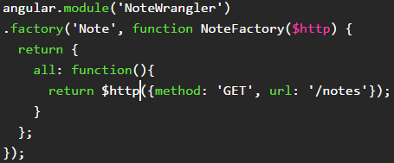

… inject the service & use it  
-> no „$“ for „Note“  
-> no $http dependency !!

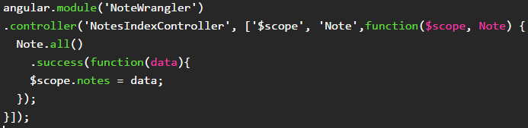

Fun External Service: Gravatar -> graphical avatar  
-> use your picture, wherever you go !!  
-> default-Size -> 80

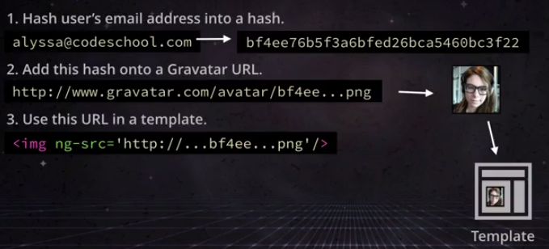

MD5 hash



There you go:  
-> toString (from number)  
-> method „generate“

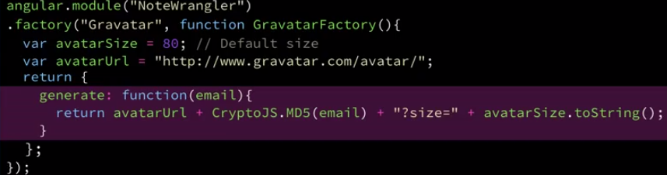

Simplify -> anonymous function

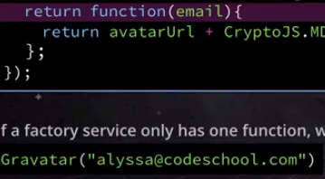

Pass as param …

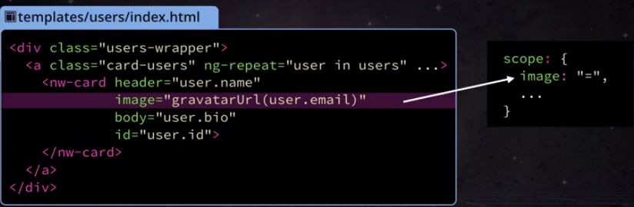

… use in template

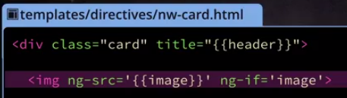

Interesting: JSON is built-in -> no String conversion required !!



… inject other providers



Refactor factory into provider:

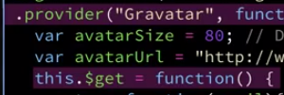

… set size before everything else  
-> GravatarProvider -> function pointer !!

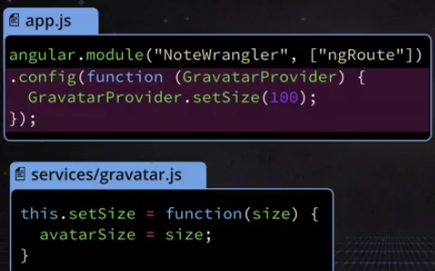

Resources -> standard calls

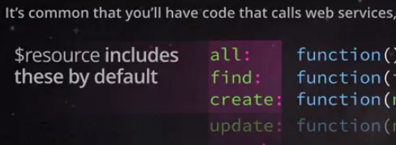

… one for all !

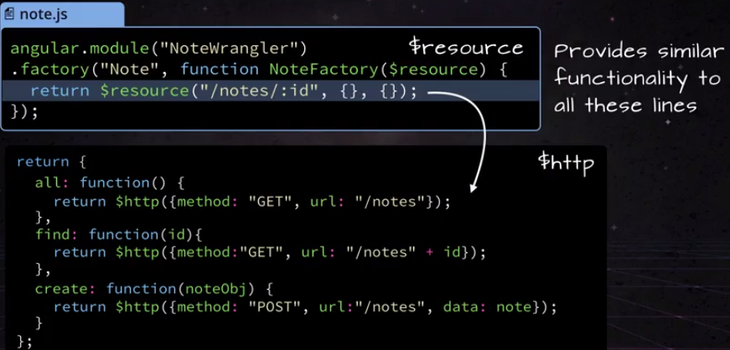

… and changed call

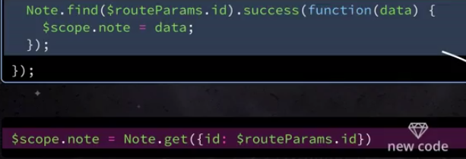

… just shorter

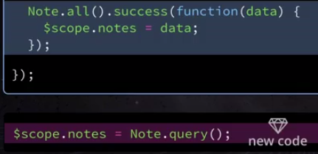

… and update (??)

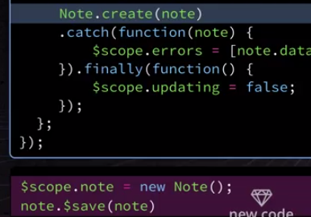

… earlier ??



… delete reserved word on IE

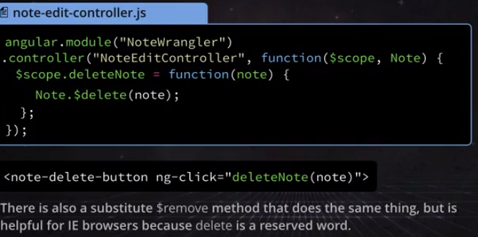

… custom update

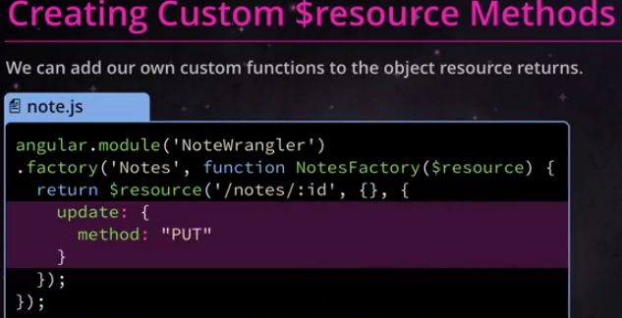

------------------------  
4  
----------------------

Access to parent methods  
-> that caret is for real !

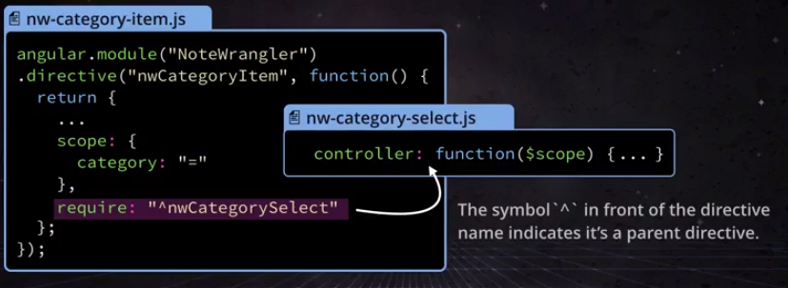

… how to call it

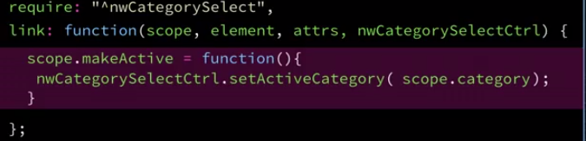

… change class (i.e. style) based on setting  
if (categoryActive()) {addClass(„active“)}

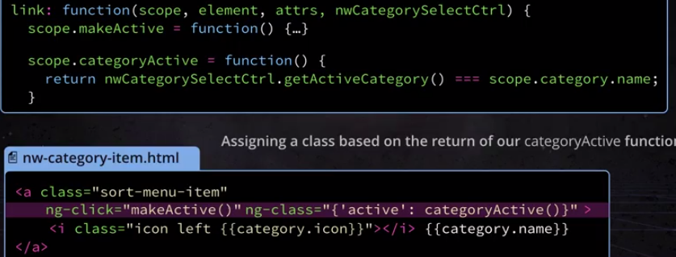

Excercise 4.5 -> create list via directive & controller



Filter filter



e.g. only „questions“

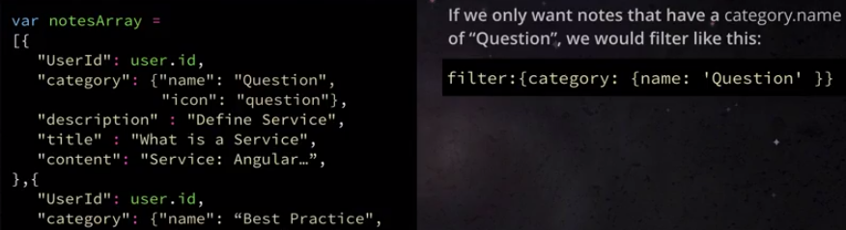

… usage

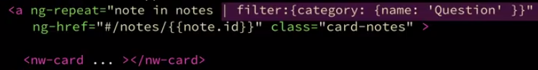

… actually

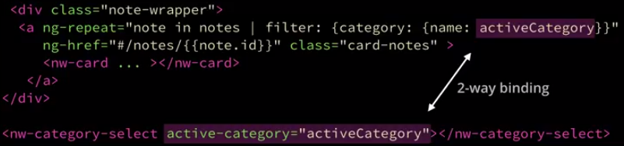

Search all properties

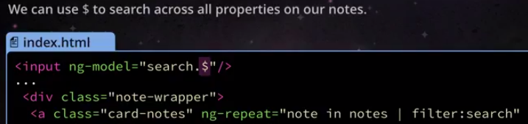

Vendor libs

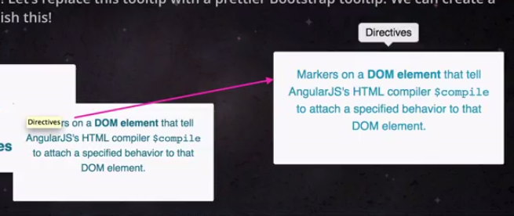

Overwrite default attr

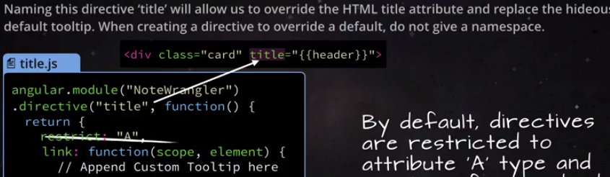

Wait for load to complete (one whole event loop, side-effect of $timeout)

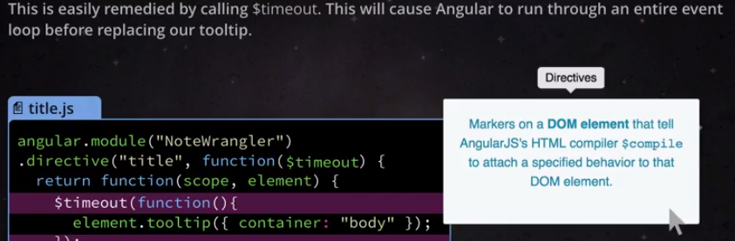

Cleanup

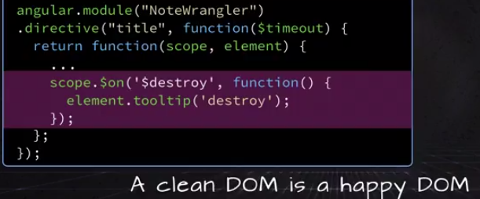

Controller <-> link

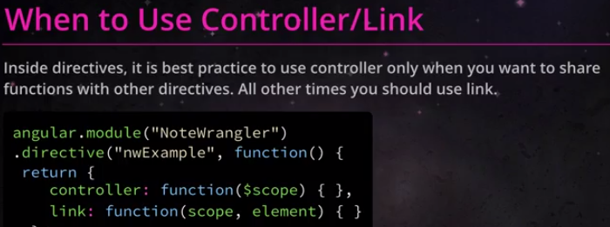

Remember to switch to lower case



Custom attribute (Exercise 4.12)

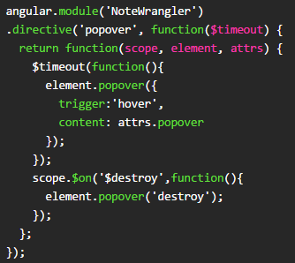

… usage

